Employee Motivation

**What is employee motivation?**

Employee motivation is the enthusiasm, energy level, commitment, and amount of creativity that an employee brings to the organization on a daily basis.

Motivation is derived from the Latin word “movere,” which literally means movement. Therefore, all the definitions that you would read in books or in the dictionary related to the fact that motivation is behavior, and one needs to channel this behavior in order to achieve desired goals and results.

**Types of employee motivation**

An organization needs to understand for a fact that not employees are clones. They are individuals with different traits. Thus, effectively motivating your employees will need to acquire a deeper understanding of the different types and ways of motivation.

Therefore, you will be able to categorize your employees better and apply the right type of motivation to increase the level of [employee engagement](https://www.questionpro.com/workforce/employee-engagement.html) and employee satisfaction. Some employees respond better to intrinsic motivation, while others may respond better to extrinsic motivation.

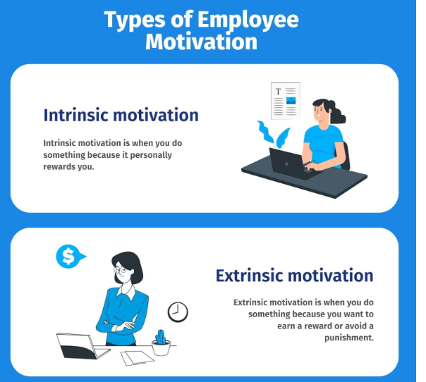

### Intrinsic motivation

Intrinsic motivation means that an individual is motivated from within. He/she has the desire to perform well at the workplace because the results are in accordance with his/her belief system.

An individual’s deep-rooted beliefs are usually the strongest motivational factor. Such individuals show common qualities like acceptance, curiosity, honor, and desire to achieve success.

Research has shown that praise increases intrinsic motivation, and so does positive [employee feedback](https://www.questionpro.com/blog/employee-feedback/). So if you are a manager, supervisor, or in a leadership role, please be intentional with your feedback or praise. Make sure it is empowering and that your employees understand your expectations.

### Extrinsic motivation

Alternatively, extrinsic motivation means an individual’s motivation is stimulated by external factors- rewards and recognition. Therefore, some people may never be motivated internally, and only external motivation would work with them to get the tasks done.

Moreover, research says extrinsic rewards can sometimes promote the willingness of a person to learn a new skill set. Additionally, rewards like bonuses, perks, awards, etc., can motivate people or provide tangible feedback.

## The importance of employee motivation

According to psychologists, self-realization is a very human thing. Moreover, it is our basic nature to nurture something and see it flourish. It is applicable to most things we do in our day-to-day life. Hence, this is true for both social and societal spaces.

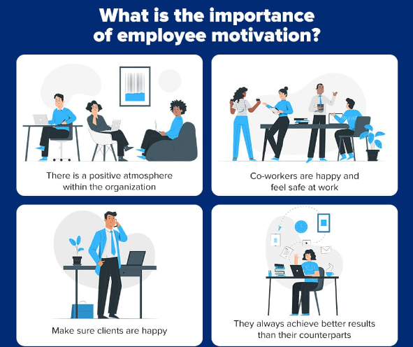

Undoubtedly, motivation plays a very important factor in a human’s life. Therefore, motivated employees take the initiative, are eager to take up additional responsibilities, and are innovative and go-getters.

Motivated employees ensure:

* There is a positive atmosphere within the organization
* Co-workers are happy and feel safe at work
* Make sure clients are happy
* They always achieve better results than their counterparts

Motivation, therefore, plays a very important factor and ensures employees remain active and contribute their best toward their organization. Furthermore, a high level of motivation leads to a lower level of [employee turnover](https://www.questionpro.com/blog/employee-turnover/).

In the next section, you will learn about the 10 simple ways to motivate your employees. Forbes elaborates that another crucial factor for managers is to understand the difference between employee motivation and engagement. Making an effort to understand the difference will, again, lead to lower levels of turnover rates.

**Top 10 ways to motivate employees**

If you are looking for ways to motivate your employees at work, here are the five simple ways of making it work:

1. **Employee motivation surveys:** Use an online survey software or platform to conduct employee motivation surveys.
2. **Employee satisfaction surveys:** Employee satisfaction depends on a ton of factors such as work environment, infrastructure, roles, responsibilities, etc. Conducting [employee satisfaction surveys](https://www.questionpro.com/blog/employee-satisfaction-survey-questions/) will help Managers understand dissatisfaction factors and act on them.
3. **Recognization:** Recognition helps create a healthy bond between the employer and employees.
4. **Focus on intrinsic rewards:** Extrinsic rewards fade very quickly. Focus on motivating your employees from within.
5. **Autonomy, not bureaucracy:** Micromanagement is the worst thing you can do as a manager. If you have hired people with certain skillset let them do their job, be a facilitator, not a dictator.
6. **Create an amazing work environment:**  Creating a good atmosphere will motivate your staff.
7. **Be a visionary:** Lead with vision. Employees need to know their efforts are driving something important. They need to know their destination and, more importantly, the path that will take them there.
8. **Act on soliciting ideas and suggestions:**Now that you have conducted surveys, you have received feedback from your employees. Ensure that the ideas, suggestions, and grievances that they have put forth will look into and addressed in a timely fashion.
9. **Career-pathing:** Having a career growth plan with clearly mentioned roles and responsibilities is crucial to employees. Therefore, make sure that you sit down with every employee and come up with a career plan that is transparent and communicated clearly.
10. **Provide flexibility:** Not all employees are alike. Therefore, you should allow some flexibility within reason, and your employees will be happy and motivated.

**Herzberg’s employee motivation theory**

Herzberg’s employee motivation theory, or two-factor theory, says there are two factors to which an organization can adjust to influence the levels of motivation at the workplace.

The two factors identified by Herzberg are:

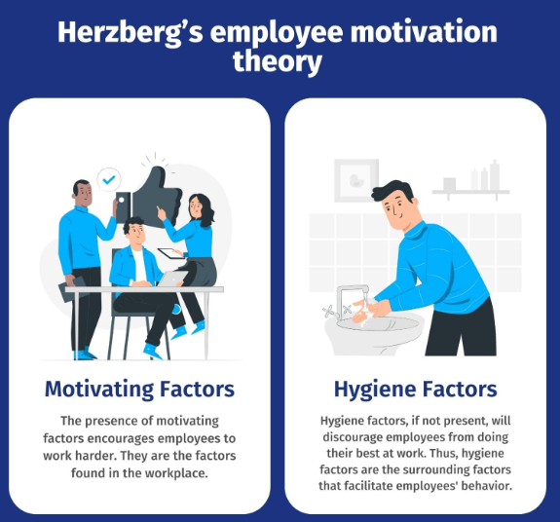

1. **Motivating factors:** The presence of motivating factors encourages employees to work harder. They are the factors found in the workplace.
2. **Hygiene factors:** Hygiene factors, if not present, will discourage employees from doing their best at work. Thus, hygiene factors are the surrounding factors that facilitate employees’ behavior.

Here are some of the examples of motivators and hygiene factor

|  |  |
| --- | --- |
| **Motivators** | **Hygiene Factors** |
| Recognition | Security |
| Growth | Company policies |
| Achievements | Salary |
| The work itself | Work conditions |
| Responsibility | Manager/supervisor |

There are 4 statistics that are involved here:

* **High hygiene & high motivation**It is an ideal situation any manager or supervisor would want to achieve. Here all the employees are happily motivated and have very few grievances.
* **High hygiene & low motivation**In this situation, employees have very few grievances but are also not highly motivated. A good example of this situation is that employees are paid well, but the work is not very interesting. Employees simply collect their pay cheques and leave.
* **Low hygiene and high motivation**Employees are highly motivated but also have numerous grievances, particularly when the work is extremely interesting, but the employees are not paid as per the market standard.
* **Low hygiene & low motivation**No point in guessing, it is obviously a pretty bad situation. Here neither the employees are motivated, nor the hygiene factors are in place.

**How to use Herzberg’s theory in practice?**

Herzberg’s motivation theory can be used to improve employee motivation in the workplace by identifying and addressing the factors that drive or detract from motivation. To implement the theory:

1. Primarily rectify and change bureaucratic company policies. Thus, make sure your Human Resources is in line with what other organizations offer, and they know the leadership’s expectations. Therefore, keeping both in mind, drafting policies that are a win-win for everyone.
2. In addition, ensure your managers are also mentors and not just bosses. Each employee should be respected and supported.
3. Organizational culture plays a very crucial role here.
4. Make sure the compensation, perks, and bonuses are as per the market standards. Hence, if you don’t compensate your employees well, why would they show interest in taking any initiatives?
5. Employees will be satisfied and find their jobs meaningful if their jobs are constructed well.
6. Delegate your employees’ responsibilities, and make them feel valued. Respect their individuality, listen to their feedback seriously, and particularly take action wherever necessary.

Employee Satisfaction

## ****What is Employee Satisfaction?****

‍

Employee satisfaction is a term that is used to describe if [employees](https://www.peoplehum.com/glossary/employee-3/) are happy and fulfilling their desires and needs at work. The crucial factor with employee satisfaction is that satisfied employees must do the job and make the contributions that the [employer](https://www.peoplehum.com/blog/effective-leadership-strategies-talk-with-mark-crowley/) needs.

Employee satisfaction is a wider term that is used by the Human Capital industry to describe how satisfied or content employees are with elements like their jobs, their employee experience, and the organizations they work for. Employee satisfaction is one key metric that can help determine the overall pulse of an organization, which is why many organizations employ regular surveys to measure employee satisfaction and track satisfaction trends over time. A high satisfaction level shows that employees are happy with how their employer treats them

Often, the term employee satisfaction is used interchangeably with [employee engagement](https://www.peoplehum.com/glossary/employee-engagement-2/); however, while engagement is one-factor influencing overall satisfaction (and it may be said the reverse is also somewhat true), the two are not the same.

Satisfaction, which is important for retention, is not necessarily a predictor of performance, while engagement—which indicates an employee’s passion for their work, among other things—is directly tied to output. Ideally, satisfaction occurs as a result of both factors like compensation and benefits as well as less-tangible elements like engagement, recognition, and strong leadership.

If an organization fails to address both the sides of the equation, they might find they have a complacent team made up of materially satisfied employees who are content to do only what is necessary to remain employed, or a staff of highly engaged employees who are performing well while they look for new opportunities at companies more willing or able to fill their material needs.

‍

## ****How do you achieve employee satisfaction?****

‍

#### **1. Be Realistic With Your Expectations**

‍

At the root of a lot of stress, anxiety, and frustration that many employees feel are unrealistic expectations from the organization. As a leader, it’s your responsibility to make sure employees are not feeling pressurized/stressed out work or overwhelmed, they likely won’t have the courage to raise that as an issue. This might be hard for you to do depending on what the organization’s goals are, but more than anything you should be having an open mindset and honest discussions with your team to see if expectations are too high.

‍

#### **2. Recognize Good Work**

‍

Recognizing your employees is one of the easiest and cheapest ways to increase job satisfaction. The only thing it requires of you is to be more mindful of what’s going on around you. Increasing your [emotional intelligence](https://www.peoplehum.com/glossary/emotional-intelligence/) will help you become more mindful and appreciative of what your team is doing.

‍

#### **3. Focus On The Long Term**

‍

Short-term thinking or looking forward to “quick wins” are not only bad for [business](https://en.wikipedia.org/wiki/Business) but can be incredibly frustrating for employees. In order for employees to get motivated, they need to see the similar long term vision that the senior leadership team has. This plays into not only having a mission and core values that you adhere to because the mission is long term and can get employees excited.

‍

#### **4. Communicate More**

‍

Remember, there’s no such thing as excessive communication. Also, the lack of communication is the source of a lot of frustration in the workplace. Knowledge is power, so there’s no reason why you shouldn’t want to empower your employees with as much as available. Work on creating a culture of open and honest communication within your team. That feeling of safety and comforts of saying whatever you want to anyone on your team is a key component of a successful team.

‍

#### **5. Care About Employee Well-being**

‍

Showing employees that you genuinely care for their well-being is one of the most effective ways to increase job satisfaction.

‍

#### **6. Offer Opportunities For Learning**

‍

Personal growth is arguably the most important factor in employee engagement. When employees stop learning, they plateau and get bored, eventually looking elsewhere for stimulation. You can stop this by applying programs for continuous learning. Employees will love you for it.

‍

#### **7. Give Frequent Feedback**

‍

Employees want feedback vigorously and aren’t as sensitive as you might think. There is no need to be rude with your feedback, but if you are straightforward and honest, employees will respect that. Make time for regular feedback by scheduling one-on-ones once a month with every individual of your team, and create more of those informal opportunities for conversation.

‍

#### **8. Don’t Focus Too Much On Perks**

‍

Perks are nice-to-have, but there is no need to put too much emphasis on perks. There is one caveat though. They say that the one perk that does make a difference is flexible time. Employees just love the fact that they are trusted enough to have some flexibility in their schedule.

‍

#### **9. Empower Employees**

‍

For employees to be satisfied at work, they need to feel like they’re in control. They should feel like they have the autonomy they need to do amazing work that they can be proud of.

‍

### **What is the difference between employee satisfaction and employee engagement?**

‍

**Employee engagement** is a term that occurs when workers are committed to helping their companies achieve all of their goals. Engaged employees are highly motivated to show up to work every day and do everything within their power to help their companies succeed.

‍

**Employee satisfaction** is the state where employees are enjoying their job — but not necessarily being engaged with it. Imagine the employee is flexible to who shows up to work early and leave late without contributing much or breaking a sweat

### **What are some employee satisfaction ideas?**

‍

#### **A. Respect them**

‍

It goes without saying that every individual employee must feel respected by their managers and colleagues. A lack of respect in the workplace is a poison for which there is no medicine.

‍

#### **B. Listen, listen some more**

‍

Managers should maintain an open-door policy and must encourage the staffs to approach them to ask questions, share ideas, and voice concerns.

‍

#### **C. Be transparent**

‍

Few things are equally important in modern business as much as transparency is. They might not always like what they hear, but they’ll respect you for being open and honest. It makes sense to tell it like it is when you’re able to do so rather than sugarcoating

‍

#### **D. Make space for creativity**

‍

Creativity brings out the uniqueness in an individual. When an organization makes space for Creativity, employees feel more connected towards organisation and productivity tends to increase

‍

#### **E. Accept mistakes**

‍

We all make errors from time to time. No big deal. Smart people will learn from them.

‍

#### **F. Training and skills development**

‍

The development of skills is good for business and good for morale, if it is done in the right way. The more sceptical employees may say that you are only doing this to make more money, but good managers are great believers in career development and making bright staff even brighter.

‍

#### **G. Create a wonderful environment**

‍

Having a positive workplace not only pumps up the work environment and employees but also brings in positive vibe into the office

‍

#### **H. Rewards**

‍

Pay, perks, benefits, bonuses. Be very careful about taking away even small perks.

‍

#### **I. Help staff to bond with one other**

‍

This is of the most important aspect for big and small companies alike. It used to be so much easier when there were just 10 of employees. Team outings, mentoring, messing on boats…These things can help employees form the bonds that they need to enjoy work.

‍

#### **J. Give recognition**

‍

If an employee has done something remarkable then make sure to thank them and recognize. And beware that managers who steal the credit will cause ill-feeling while undermining themselves. And that never ends well.

‍

#### **K. Be polite**

‍

There is nothing wrong with ‘please’ and ‘thank you’ in a business environment, and being polite is always appreciated and employees also love it.

‍

#### **L. Embrace remote working**

‍

Remote working not only minimises commuting costs but also hassles, and can actually help in increasing productivity.

‍

#### **M. Be tolerant**

‍

When a manager is tolerant, employees tend to understand things much better with much better quality.

‍

#### **N. Mentoring and coaching**

‍

These are two different things, and both have their positives. Mentoring is being able to chat with a senior manager about all kinds of things. Coaching is more specific and targeted at improving skills in various areas, rather than employee benefits.

‍

#### **O. Never pay staff late**

‍

If there is one thing employees will hate you for, then it is a late payment. Pay them early, Keep them Happy

**Key reasons for employee dissatisfaction**

* Low compensation
* Lack of Career growth
* Poor Management
* Poor Relation with Co-workers and Managers
* Lack of Appreciation and Recognition
* Poor Work-Life Balance

## Here are the 9 Best Practices to Keep Employee Satisfaction High

### 1. A Positive Work Environment

### 2. Feedback

### 3. Rewards and Recognition

### 4. Work-life Balance and Employee Satisfaction

### 5. Involve and Engage your Employees

### 6. Develop Employee Skills

### 7. Evaluate and Measure Employee Satisfaction

### 8. Employee Well-being

### 9. Clearly defined Goals and Objectives

and Commitment

# What is Employee Commitment?

Employee commitment has been defined as, “The strength of an individual’s identification and involvement in a particular organisation. ”*

The authors who provide this definition developed a questionnaire-based tool in order to measure this construct. It describes [employee commitment](http://greatwithtalent.me/2013/10/04/six-tips-for-enhancing-employee-commitment/) using three distinct components:

● A strong belief in and acceptance of an organisation’s goals;  
● Staff motivation or willingness to exert considerable effort on behalf of the organisation they work for;  
● A strong desire to maintain membership to the organisation.

## Types of Employee Commitment

### 1. Affective (Emotional) Commitment

This type of employee commitment is the closest to what one might intuitively consider commitment to be. It encapsulates the idea of an emotional identification with the organisation. This leads to an increased desire to contribute and perform, as well as maintain citizenship of the organisation.

There is an enormous amount of research demonstrating the positive benefits of affective staff commitment, both to the organisation and the individual. It is for this reason that we concentrate on this type when considering what gives rise to employee commitment.

### 2. Normative Employee Commitment

This refers to a perceived obligation to remain with the organisation. An employee can experience an obligation to perform work activities in the absence of a personal desire to do so.

This type of employee commitment typically has weaker positive relationships with staff motivation, job satisfaction etc. Though, cultural variation plays a part in the strength of the relationships between normative commitment and work behaviours.

Norms and social obligations exert more power over actual behaviour in more collectivist cultures (e.g. Turkey). This is compared to relatively individualistic contexts (e.g. the USA) where incidentally, the majority of the psychological research takes place.

### 3. Continuance Commitment

This is bound up in a very idiocentric and calculative decision-making process. Essentially, this involves the individual considering what they stand to lose should they leave an organisation. Their perceived sacrifices, together with the alternatives open to them.

Unsurprisingly, this type of employee commitment has less positive outcomes and is in fact related to higher stress. There may be increased work-family conflict and poorer performance.

Combating staff turnover with salary raises and other incentives may increase affective employee commitment through perceptions of personal competence. Yet, it could also in some instances accentuate what employees stand to lose, adding to a feeling of being ‘trapped’ (high continuance commitment), with all its negative associations.

## The Importance of Employee Commitment

In summary, organisational commitment is now regarded as a key part of investigating the health of organisations. This is done both by occupational psychologists and HR professionals.

Moreover, affective employee commitment (identification and emotional involvement with the organisation) is known to have the most positive effect on work-related behaviour and staff turnover intentions.

Monitoring this variable can give early warnings of imminent employee turnover problems. It also provides an excellent benchmark for evaluating interventions aimed at reducing staff retention difficulties (e.g. job redesign, induction and socialisation processes).

Fairness and Diversity